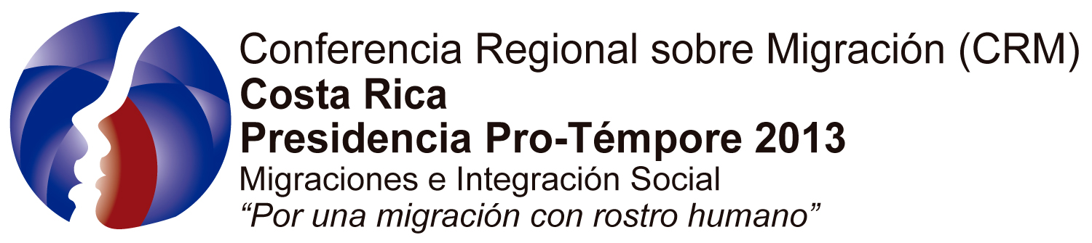  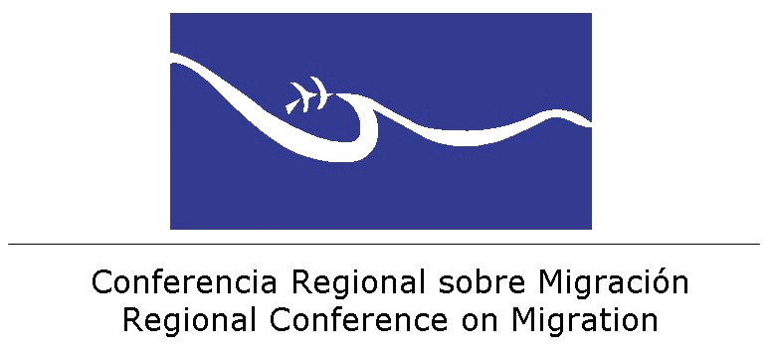 | 
Preliminary Agenda
Seminar on
Unaccompanied Migrant Children
La Antigua Guatemala, Guatemala, 27 - 28 August, 2013

The event will be divided in two main activities. The first one includes the Opening Ceremony of the Regional Forum and activities for the First Ladies’ delegations and institutions working on the subject, in order to build an agenda for cooperation. The second activity will include the Technical Seminar. The agenda below belongs to that second activity.

Day1: August 27th, 2013

Opening Ceremony
Santo Domingo del Cerro
Venue: Conventions Center

09:30 to 10:00 Transfer of accredited technical delegations from Camino Real Hotel to Conventions Center of Tenedor del Cerro, Annex Hotel Casa Santo Domingo.

10:00 to 10:30 Participants registration/Coffee Time
Female Marimba Concert

11:00 to 11:30 Welcome and opening

11:30 to 13:00 First Ladies and Authorities Forum

13:00 to 13:15 Cultural event.

13:15 to 15:00 Lunch for First Ladies, their delegations, Technical Delegations accredited before the RCM and special guests.
Venue: Santo Domingo del Cerro

15:00 Closing ceremony.

-------------------------------------------------------------------------------

Technical Meeting
Rooms Nobles and Caballeros, Camino Real Hotel

14:30 to 15:00 Transfer of Delegations
Delegations will be transferred to Camino Real Hotel, venue of the Technical Seminar.

15:00 to 16:00 Plenary Session: Overview
      - Results of the Workshop on Migrant and Refugee Boys, Girls, and Adolescents, held in San José, Costa Rica on March 27-28, 2012, and Regional Guidelines to Protect Unaccompanied Migrant Children in Cases of Repatriation. (TS-RCM)
      - Presentation regarding the Regional Study on Migrant Childhood in Central America and Mexico (IOM-ILO)
      - Recommendations of the Committee on the Rights of the Child in the context of international migration. (UNICEF)

16:00 to 17:15 First Panel: Strategies for Prevention
Moderator: ILO (Noor Denkers) and UNICEF

17:15 to 17:30 Coffee Break and end of first day’s session.

19:45 to 20:00 Transfer of delegations to the Capuchinas Convent

20:00 to 22:00 Welcoming Reception (First Ladies, First Ladies’ delegations and technical delegations)
Venue: Capuchinas Convent

Day 2: August 28, 2013

08:30 to 09: 45 Second Panel: Consular Protection Strategies, Procedures and Repatriation Agreements.
Moderator: Carlo Giron PMH

09:45 to 11:00 Third Panel: Reception and Psychosocial Care Strategies.
Moderator: UNHCR (Luis Diego Obando)

11:00 to 11:15 Coffee Break

11:15 to 12:30 Fourth Panel: Strategies for Social and Family Reinsertion and Integration
Moderator: IOM (Agueda Marin)

12:30 to 14:30 LUNCH

15:00 to 16:30 Conclusions and Recommendations per country

16:30 to 17:30 Countries’ presentations

17:30 to 18:00 Closure of the Technical Seminar

