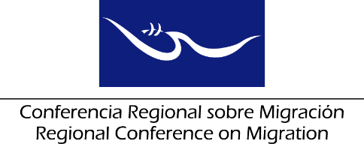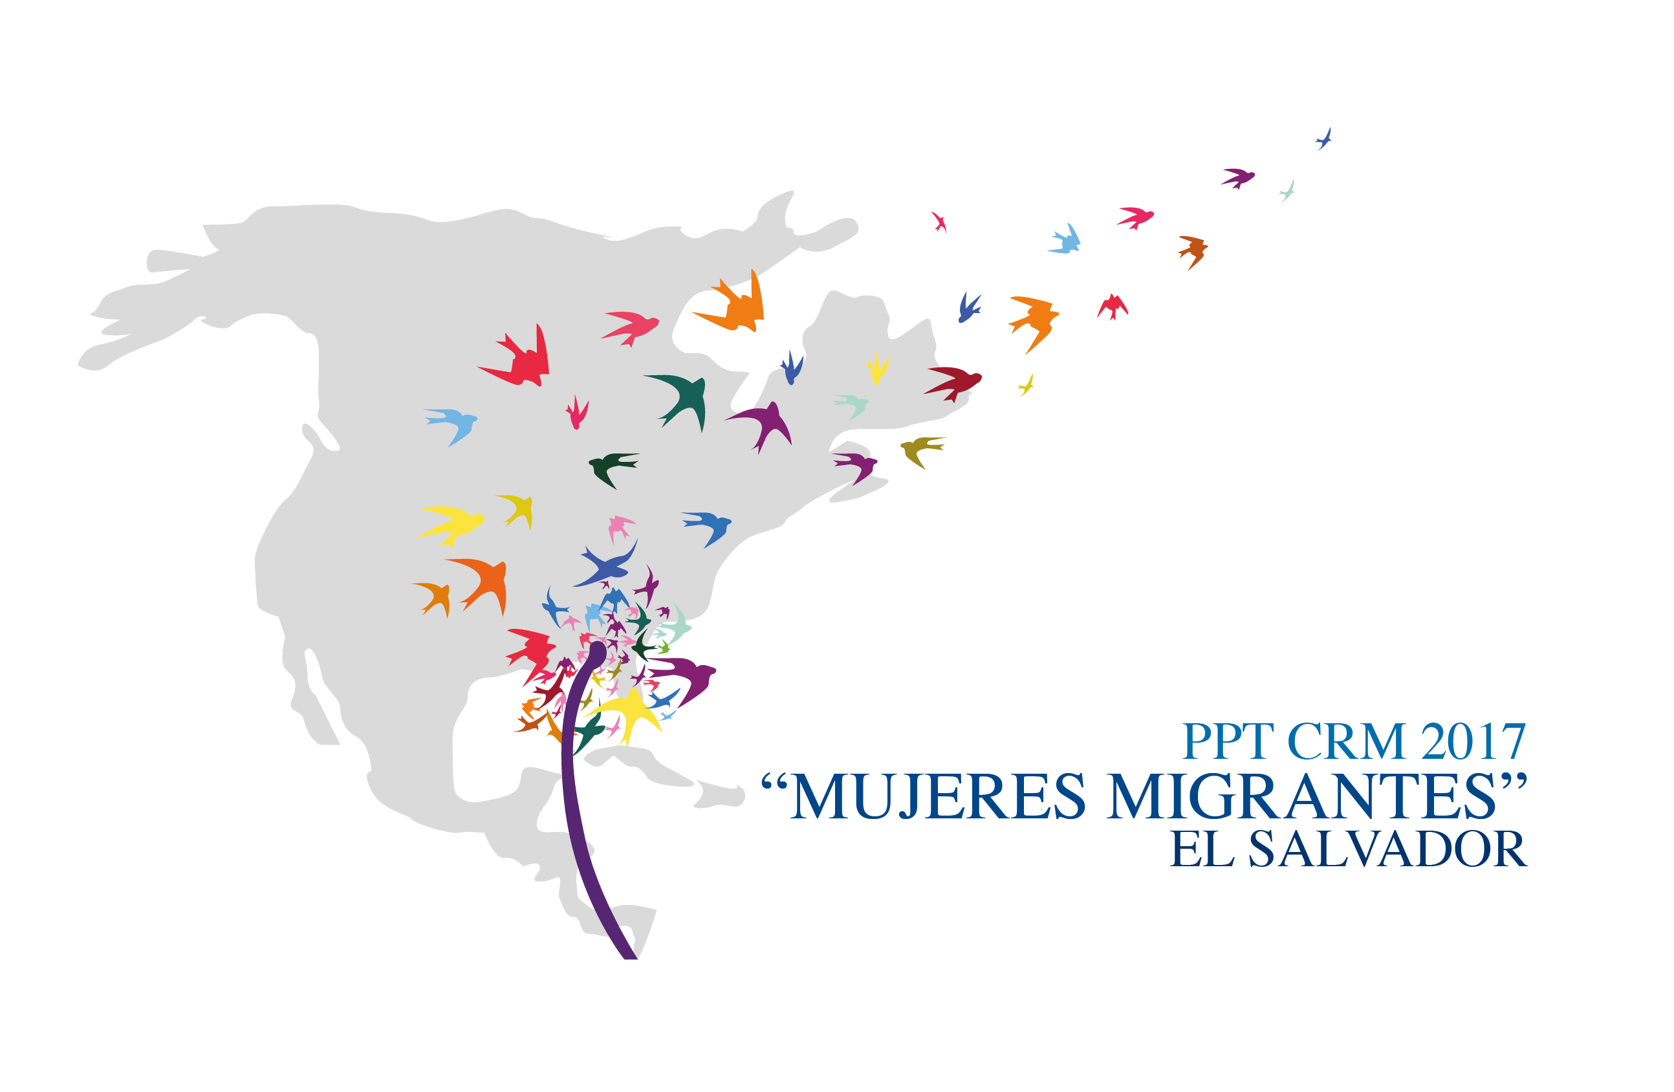

Meeting of the Liaison Officer Network for Consular Protection
Regional Consultation Group on Migration (RCGM)
San Salvador, El Salvador

November 27, 2017

PRELIMINARY AGENDA

08:30 – 08:35 Approval of the agenda
[Leads: PPT]

08:35 – 09:45 Reports of the Member Countries on their new efforts/effective practices in consular protection.
[Lead: All delegations (5 minutes for each delegation)]
Note: Please only report on NEW efforts and practices, and respect the established time limit of 5 minutes for each presentation.

09:45 – 10:00 Update on the establishment of joint consulates and on preventive protection actions.
[Lead: All delegations]

10:00 – 10:15 Coffee Break

10:15 – 10:30 Presentation of the Regional Diagnosis on Migrant Care Centers.
[Leads: RNCOM-IOM]

10:30 – 10:45 Presentation of a concept note for a Workshop on consular protection of migrant workers.
[Lead: ILO-IOM]

10:45 – 11:00 Presentation of the virtual course on protection to migrants affected by crises and activities related to the MICIC initiative.
[Leads: IOM]

11:00 – 11:30 Proposals of new activities
[Lead: All delegations]
- Presentation of the ICRC proposal to hold an event on missing migrants, in 2018. [Leads: ICRC]

11:30 – 12:45 Draft of the report on the meeting of the Network, to be submitted to the Regional Consultation Group on Migration (RCGM)
[Leads: PPT]

12:45 Closure

