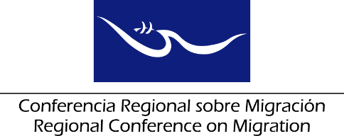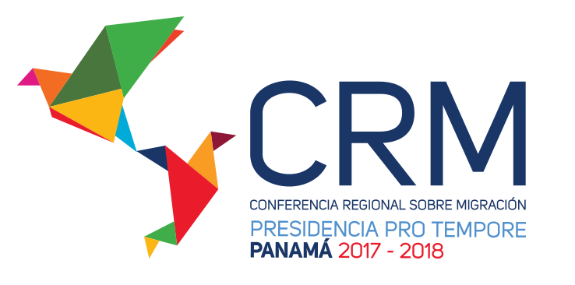

**Meeting of the Liaison Officer Network for Consular Protection**

**Regional Consultation Group on Migration (RCGM)**

Panama City, Panama

# 19 November 2018

**AGENDA**

**________ Hotel, ________ Room**

08:30 – 08:35 Approval of the agenda ***[Lead: PPT]***

08:35 – 09:45 Reports of the Member Countries on their new efforts/effective practices in consular protection.

***[Lead: All delegations (5 minutes for each delegation)]***

Note: Please only report on NEW efforts and practices and respect the established time limit of 5 minutes for each presentation.

09:45 – 10:15 Presentation of the study that includes the best practices, legal frameworks and other inputs that allow the possibility of opening joint consulates among interested RCM Member Countries, focusing on joint protection.

***[Lead: IOM]***

10:15 – 10:45 Coffee Break

10:45 – 11:15 Space for International Organizations to present progress/proposals for the consular protection. ***[Lead: International Organizations]***

11:15 – 11:30 Free Spot ***[Lead: Mexico]***

11:00 – 11:30 Dialogue with RNCOM ***[Lead: PPT-*** ***RNCOM]***

11:30 – 11:45 Proposal of new activities

***[Lead: All delegations]***

11:45 – 12:30 Draft and reading of the report on the meeting of the Network, to be submitted to the Regional Consultation Group on Migration (RCGM)

***[Lead: PPT]***

12:30 Closure