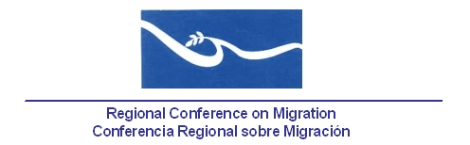

**Meeting of the Liaison Officers Network to Combat Migrant Smuggling and Trafficking in Persons**

**Park Inn Hotel, Red Room (3rd floor)**

**San Jose, Costa Rica**

**25 June, 2013**

***AGENDA***

07:30 – 08:30 Registration of participants.

08:30 – 08:45 The meeting begins. Approval of the agenda and establishment of the Drafting Committee. ***[Lead: PPT]***

08:45 – 09:30 Report by the countries on challenges faced and progress made to combat human trafficking and migrant smuggling since the last meeting of this Liaison Officers Network. (5 minutes per delegation). ***[Lead: All delegations]***

*[Background: Regular reports by delegations.]*

09:30 – 09:50 Report on the implementation of the proposal of indicators prepared by the IOM as per request of Member Countries, which goal is to reflect the objectives of the Palermo Protocols and present the progress towards achieving them. ***[Lead: TS]***

* + - *During the most recent meeting of this Network, held in Panama in December 2012, Central American Countries and Mexico expressed that they would work on the use of this tool and share their results with the TS of the RCM in order to prepare the corresponding report.*

09:50 – 10:15 Presentation of the Regional Strategy against Trafficking in Persons "Not everything is as it seems", and Presentation of main research results on labor trafficking in Central America. **[Lead: IOM]**

10:15 – 10:30 Progress report regarding the agreements reached within the Regional Central American Coalition against Trafficking in Persons. ***[Lead: Costa Rica]***

10:30 – 10:45 Regional Project in the Field of Migrant Smuggling ***[Lead: UNODC].***

10:45 – 11:00 Presentation or dialogue with the RNCOM ***[Lead: RNCOM].***

11:00 – 11:15 Coffee break

11:15 – 11:45 Proposals of new activities. ***[Lead: All delegations]***

11:45 – 13:00 Preparation of the report of the network’s meeting for the RCGM.

***[Lead: PPT]***