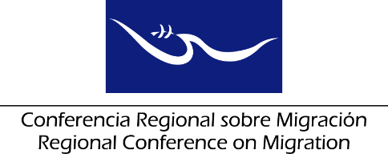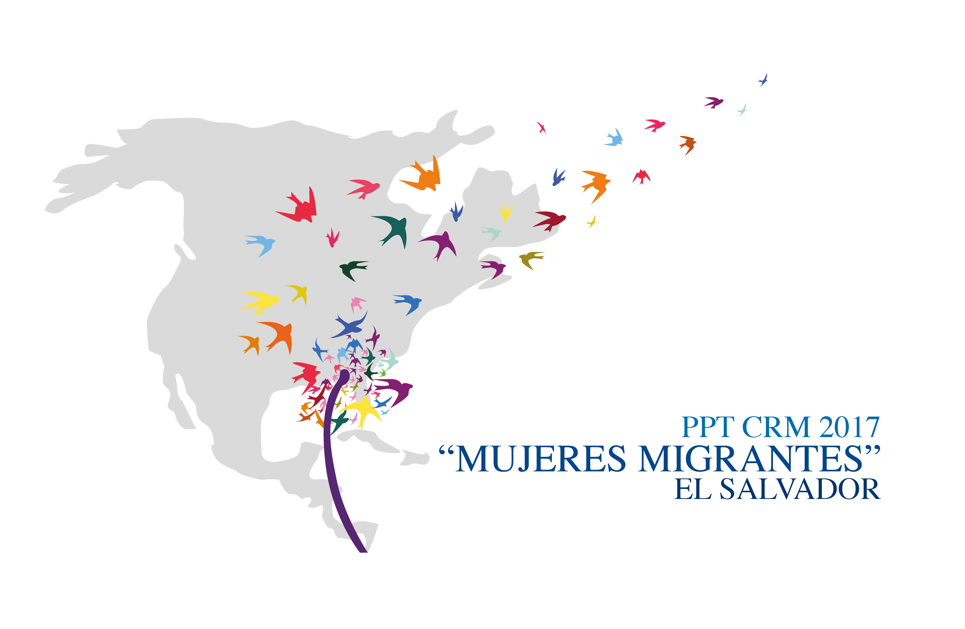

Liaison Officers Network for the Protection of Migrant Girls, Boys and Adolescents
Regional Consultation Group on Migration (RCGM)

November 15th, 2017

PRELIMINARY AGENDA

8:30 – 8:45 Welcoming remarks and approval of the agenda
[Leads: PPT]

8:45 – 9:45 Country reports on new efforts/best practices for the assistance and protection of migrant girls, boys and adolescents.
[Lead: All delegations (5 minutes per delegation)]

Note: you are kindly requested to restrain your presentation only to RECENT efforts/practices and to keep the length of your presentation to a maximum of five minutes.

9:45 – 10:00 Progress on the development of the Strategic Plan for the Liaison Officers Network for the Protection of Migrant Girls, Boys and Adolescents of the RCM for 2017 to 2022.
[Leads: PPT]

10:00 – 10:30 Dialogue with civil society organizations on recommendations to develop joint initiatives for the provision of assistance and protection of migrant girls, boys and adolescents.
[Leads: RNCOM]

10:30 – 10:45 Presentation of the joint work with Child Fund and their interest in participating in the RCM
[Leads: Technical Secretariat]

10:45 – 11:00 Follow up on the compilation of best practices and a map of specialized actors and services relate to the protection and assistance of migrant girls, boys and adolescents.
[Leads: IOM]

11:00 – 11:20 Follow up on the drafting of a document on best practices with regards to alternatives for the detention of migrant and refugee girls, boys and adolescents.
[Lead: ICRC and UNICEF]

11:20 – 11:35 Proposals of new activities
[Lead: All delegations]

- Proposal of a Workshop on Mechanisms for the return of migrant boys, girls and adolescents.
[Leads: UNICEF - IOM]

11:35 – 12:05 Preparation of the Network’s report for the RCGM
[Leads: PPT with support of the TS]

12:05 Closure

