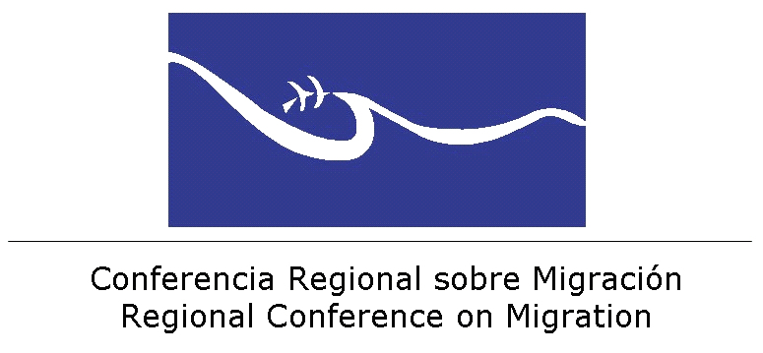 | 
FIRST MEETING
AD-HOC GROUP ON MIGRANT CHILDREN
Guatemala City, 28-29 August, 2014

Thursday, 28 August

8:00 – 8:30 Registration of Participants
8:30 – 9:00 Opening session
9:00 – 9:30 Current situation of migrant children in the region.
9:30 – 10:00 Coffee Break
10:00 – 10:30 Instruments approved within the RCM framework and considerations related to the Extraordinary Declaration (XIX RCM, 2014)
10:30 – 11:15 Regional Mechanism for the Comprehensive Protection of Migrant and Refugee Boys, Girls and Adolescents and its Annex (Definitions and Guiding Principles)
11:15 – 12:30 Reviewing of regional initiatives and meetings (Reports by interested countries)
12:30 – 13:30 Lunch
13:30 – 15:15 Principle of the Best Interest of the Child and its applicability. Inter-agency
presentation (IOM, UNHCR, UNICEF)
15:15 – 16:00 Plan for Regional Actions for the Consular Protection and actions in countries of transit and destination
      - Actions for the reception of foreign children and their immediate assistance and protection
      - Protective actions in integration processes
      - Protective actions in return processes
16:00 – 16:15 Coffee Break
16:15 – 17:30 Plan for Regional Actions for the Consular Protection and actions in countries of transit and destination (continues)

Friday, 29 August, 2014

8:00 – 10:00 Plan for Regional Actions for Psychosocial Care and Reception
- Protective actions during reception and reintegration processes in the countries of origin
10:00 – 10:30 Coffee Break
10:30 – 11:30 Summary of first day and participation of the Vice-Ministers from El
Salvador, Guatemala and Honduras.
11:30 – 14:00 Plan for Regional Actions for Reintegration/Integration
- Protective actions during reception and reintegration processes in the countries of origin
14:00 – 15:00 Lunch
15:00 – 17:00 Plan for Regional Actions of Prevention
- Protective actions before leaving
- Actions to promote settlement
17:00 – 17:15 Coffee Break
17:15 - 18:00 Defining a follow-up route and conclusions.
18:00 – 18:30 Closing

