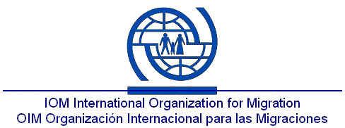
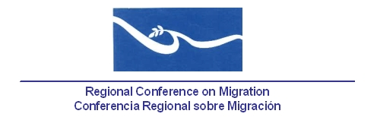

Regional Work Meeting
Consular Departments – Ministries of Foreign Affairs

DESCRIPTION AND BACKGROUND

The training process of diplomatic representations and consular officials from the region on trafficking in persons is a result of the agreements reached by the governments during the XII Meeting of the Regional Conference on Migration. Since then, countries expressed their interest and commitment on carrying out these types of initiatives as strategic activities to fully combat this crime.

So, within the framework of the Training program on trafficking and coordination among government officials of member countries, the International Organization for Migration (IOM), based on the said agreements, created a specific project for training consular authorities.

The first stage of this Project started in 2009 with a meeting of the heads of consular affairs of Central America and Mexico. During this meeting, the objectives and scope of the training project were presented and the strategic lines to be implemented in each country were specified and validated. These lines included not only the training process, but also the definition of a course of action for the protection and the assistance to victims.

Following up on the agreements, several workshops were held during 2010 and 2011 with the participation of consular officials appointed in Southern Mexico, Guatemala, El Salvador, Honduras, Costa Rica, Nicaragua, Panama and Belize. These workshops were focused on strengthening the capacities for the detection, protection and assistance to victims of trafficking, as well as clarify and strengthen the national reference system, in order to promote in each country an appropriate assistance, sensitive with the needs of people affected by this crime.

In this same period, workshops were held with officials from various departments of the Ministries of Foreign Affairs in all the countries mentioned above, who received training on the basic aspects of trafficking in persons. An internal action route for the prevention of trafficking in persons and for the protection and consular assistance to victims was designed.

This proposed work meeting is part of the last stage of the process. It looks forward to integrate the work of the national workshops into a regional vision of the main challenges and achievements in the prevention, assistance and consular protection, as well as to create a consensual proposal of procedures to intervene at these levels, including a general implementation plan.

Due to the strategic importance of this meeting for decision-making, we are calling for the participation of the heads of the Consular Departments and other officials whose work is related to combating trafficking in persons in the Ministries of Foreign Affairs of Panama, Costa Rica, Nicaragua, El Salvador Honduras, Guatemala, Belize and Mexico.

VENUE AND DATE:

San Jose, Costa Rica, 28-29 August, 2012.

PARTICIPANTS:

- Head of Consular Departments of the Ministries of Foreign Affairs of Panama, Costa Rica, Nicaragua, El Salvador, Honduras, Guatemala, Belize and Mexico.
- Technical officers from the Ministries of Foreign Affairs, in charge of issues related to trafficking in persons and/or protection of vulnerable migrants.

OBJECTIVES:

- Present the results obtained during the above mentioned training process, specially the main advances and challenges of intervention on human trafficking issues.

- Develop and agree regional guidelines to intervene in cases of trafficking in persons and for the consular protection of victims.

- Build strategies for the implementation of such guidelines from the Consular Departments of the Ministries of Foreign Affairs.

AGENDA

Tuesday, August 28th

08:00 – 08:30 Opening Session

08:30 – 09:00 Presentation of the objectives of the meeting and background information

9:00 – 9:30 Break

9:30 – 11:30 Session 1
Update on Trafficking in Persons: “Understanding this crime and consular responsibilities”

11:30 - 12:30 Session 2
Presentation of the outcomes from the national workshops: “Advances and regional challenges: Prevention of trafficking in persons, protection and consular assistance for victims abroad”

12:30 – 13:30 Lunch

13:30 – 16:30 Session 3
Procedures to intervene in cases of trafficking in persons in order to protect and provide consular assistance to victims
Analysis and contents design.

Wednesday, August 29th

08:00 – 09:30 Session 3 continues
Presentation of the summary of results

09:30 – 10:00 Break

10:00 – 11:30 Session 4
Building of proposals for the implementation of drafted guidelines

11:30 – 12:30 Final remarks
Closing of the meeting

