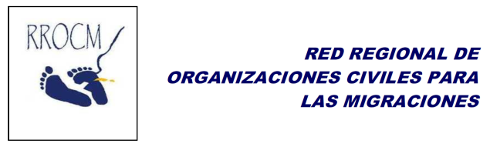
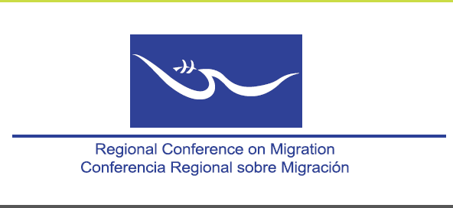

ACTION PROTOCOL
REGIONAL CONFERENCE ON MIGRATION (RCM) AND
THE REGIONAL NETWORK OF CIVIL ORGANIZATIONS FOR MIGRATION (RNCOM).

Background:
Since 1998, the Regional Network of Civil Organizations for Migration-RNCOM- actively participates in the Regional Conference on Migration-RCM- in order to strengthen dialogue with civil society on issues of regional migration. RNCOM has attended seminars and workshops of the RCM and has spaces for participation in bodies such as the Regional Consultation Group on Migration (RCGM) and the Vice-ministerial Meeting. In June 2012, the RCM in its XVII CONFERENCE "Security in the Context of Human Rights and Mixed Migration Flows” took the Decision as indicated in point seven of the document "Approve the RNCOM proposal to hold a meeting of the Ad Hoc RCM-RNCOM coordination working group to determine a common agenda and coordinating mechanisms ". The first meeting of the Ad Hoc Group was held in the city of San Salvador on February 20th and 21th, 2013. As a result of this process the present action protocol is defined and established.

Objective:
Advise government officials representing member countries of the Regional Conference on Migration, Ministries of Foreign Affairs, Immigration Offices, and focal points of the Regional Network of Civil Organizations for Migration, on the mechanisms and national, binational and regional implementation rules, of relationship and interagency and intersectoral collaboration for addressing migration from the perspective of protection of Human Rights and Development of migrants and their families.

Scope:
This protocol is applicable in member countries of the Regional Conference on Migration-RCM-both government representative institutions and RNCOM organizations.

On the representations of CRM y RNCOM

About the Proceedings:
The RCM staff members and representatives of the member organizations of RNCOM will have as performance space the regional, national and binational areas. For this purpose the Technical Secretariats of the RCM and RNCOM will write a report with the names and positions of their representatives in each country as well as the period of representation.

At Regional level, the meetings of the Regional Conference on Migration and the Working Group of the RCM will be a space for regional dialogue, review of best practices, generating agreements and pending challenges for the promotion of collaborative work.

In the case of the crime of trafficking in persons, the performance space between the RCM and RNCOM will be through focal points of each member country in the framework of the Regional Coalition against Trafficking in Persons.

In the Binational field, given the importance of the issues and collaborative generating efforts, it is suggested to promote spaces for exchange in order to coordinate and report about binational migration issues, including people seeking refugee status. In these meetings the institutions involved in the prevention, care, research and legal aspects of the crime of trafficking in persons, smuggling of migrants, developments in national legislation or decisions of a country that benefits migratory processes or other decisions country migration management change, shall be called. (eg transients in Costa Rica). These binational activities will collaborate to a better coordination between the governments and the RNCOM (focal points).

In the National field, the indicated members (RNOCM focal points and representatives from government institutions) will generate meetings to establish national coordination mechanisms in order to advance with the proposed and discussed agendas in the context of RCM; also toward the fulfillment of the agreements referred to in the context of the Ad Hoc Working Group. Both focal points and RCM members may convene other institutions and organizations involved with the migratory agenda in order to build and strengthen the intersectoral and Interinstitutional mechanisms.

In the case of the crime of trafficking in persons, the performance space will be through the establishment of focal points within Coalitions / National Taskforces against Trafficking in each RCM member country.

For action at regional level, the Technical Secretariats of RCM and RNCOM will draw up proposals for annual working plans, with semiannual compliance reviews that may be socialized in the context of RCM and the RCGM.

Communication Mechanisms
The communication process will be through the Technical Secretariats of the RCM and RNCOM, who will transfer the same to countries and national focal points. Likewise, focal points of both governmental institutions and civil society will hold constant communication with their technical secretariats, which will provide them with support to foster processes.

From the communication generated between each of the actors involved, the Technical Secretariats will prepare a semi-annual report of the working plan, identifying the progress, challenges and recognition of good practices inside action between government and civil society.

This action protocol is based on the recognition of the good practice sustained in the 1st Ad Hoc Working Group Meeting, held in San Salvador the 20th and 21st of February, 2013, meeting that allowed the definition of a common agenda and the identification of coordinating mechanisms, through the generation of dialogue and the identification of challenges and strengths to move forward together to a comprehensive approach of migration.

Document prepared by Alfredo Danilo Rivera, responsible on behalf of the American Institute for Social and Development Studies (INCEDES), focal point in Guatemala of RNCOM and Member of Executive Committee of RNCOM. Includes contributions from Irene Palma / CEO of INCEDES.
Regional Conference on Migration (or Puebla Process) XV years Magazine. 2011. Page 6.
Declaration of the XVII Regional Conference on Migration, held in Panama, on June 21-22, 2012.

