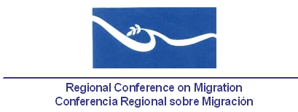

Proposed topics to be discussed in the Ad-Hoc Group, regarding the definition of a mechanism that facilitates cooperation between the RNCOM and the RCM

In compliance with Conclusion #6 from the past Regional Consultation Group on Migration (RCGM) Meeting, held on Santo Domingo, the Dominican Republic on 16 – 17 November, which reads:

“The Technical Secretariat will send the Member Countries a document with proposed topics to be discussed in the Ad-Hoc Group, regarding the definition of a mechanism that facilitates cooperation between the RNCOM and the RCM.”

The RCM Technical Secretariat presents the topics that, after the XVI RCM, were proposed by Mexico and the RNCOM for consideration of the Member Countries:

- Follow-up proposal to the Seminar on Human Rights, held in Honduras in 2011, with some suggested topics:

- Migration workers and access to rights
- Implementation of new migration legal framework and its coherence with international commitments
- Migrant children, family reunification and return
- Consular management and protection. Challenges in the region.

- Collaboration to create an assessment on the access to health services in favor of migrant population.

- Proposal to update the directory of civil society organizations that do not belong to RNCOM yet, but are involved with some governmental efforts, in order to increase the spectrum of partners within the framework of the RCM.

- Unaccompanied children’s rights protection: Through the Ad-hoc Group, identify civil society organizations members of RROCM that work for children’s rights, in order to create synergies with governmental authorities and reinforce work done by the trained Child Protection Officers.

