**CONCEPT NOTE**

**PLENARY MEETING BETWEEN THE REGIONAL CONFERENCE ON MIGRATION (RCM) AND THE SOUTH AMERICAN CONFERENCE ON MIGRATION (SACM)**

1. **BACKGROUND**

Inter-State Consultation Mechanisms on migration (ISCM for its acronym in English) refer to all regular information dialogues and policy dialogue at regional, interregional or global level among states interested in promoting cooperation in the field of migration. These intergovernmental consultative mechanisms include global migration processes, interregional forums on migration (linking two or more regions) and regional consultative processes on migration (covering one region).

The Regional Consultative Processes on Migration (RCP) are, continuous and regional dialogues of States for the exchange of information and policies dedicated to discussing specific migratory issues in a cooperative way between the States of a fixed region (generally geographic) and can be officially associated with formal regional institutions, or be informal and non-binding.

On the American continent, the trajectory of the Regional Conference on Migration (RCM) and the South American Conference on Migration (SACM) stand out as recognized and consolidated regional consultative processes on migration.

**RCM**

The RCM is a non-binding regional consultative process on migration to address migration in the region in a practical and comprehensive manner, from a technical-political level. Created in 1996 as a result of the Tuxtla Summit.

The RCM is made up by 11 countries: Belize, Canada, Costa Rica, Dominican Republic, El Salvador, the United States, Guatemala, Honduras, Mexico, Nicaragua, and Panama.

**SACM**

On the other side, the SACM is a regional consultative process on migration that seeks to generate and coordinate initiatives and programs aimed at promoting and developing policies on international migration and their relationship with development and regional integration.

The Member Countries of the SACM are: Argentina, Bolivia, Brazil, Chile, Colombia, Ecuador, Guyana, Paraguay, Peru, Suriname, Uruguay and Venezuela.

The exchange of experiences between the SACM and the RCM is not new. Both processes are very similar and share a common continent. As background of the plenary meeting, the work done by the member countries of the troikas of the RCM and the SACM during the year 2017 is highlighted.

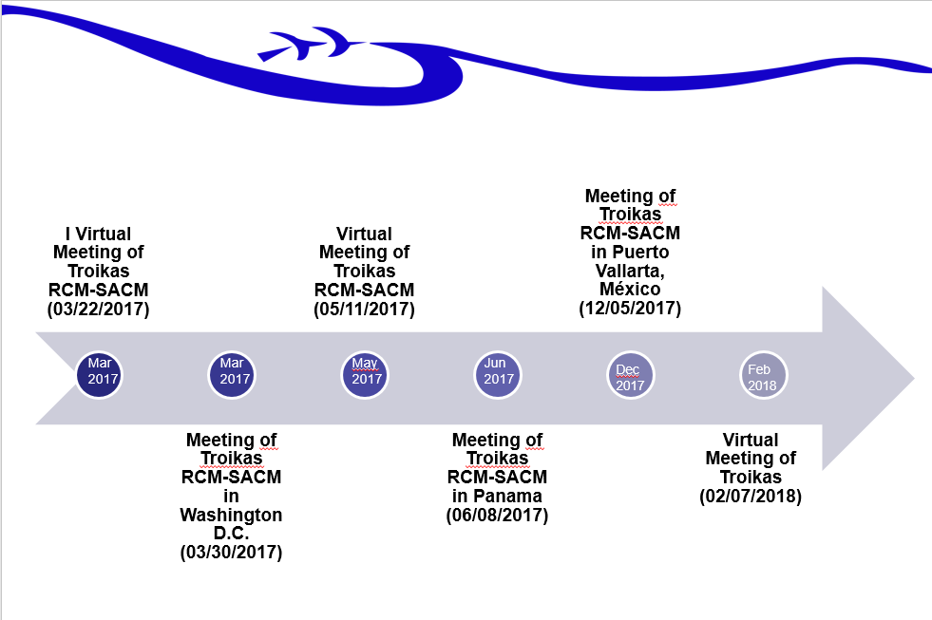

In 2017, a first virtual meeting was held in March, in preparation for the face-to-face meeting held that same month in Washington D.C. Later, in May, another virtual meeting was held and in June a meeting of an Ad Hoc Group of RCM and SACM troikas was held to prepare bi-regional inputs for the consultation phase of the Global Compact on Migration. In December 2017, in the framework of the preparatory meeting of the Global Compact, an informal troika meeting was held in Puerto Vallarta, Mexico. Recently, on February 7, the first virtual meeting of troikas was held for the year 2018, in preparation of the plenary meeting.

* **TOPICS OF THE MEETING**

As agreed between the Troikas of the RCM and the SACM, the plenary meeting will cover two major topics:

1. Global Compact for a Safe, Orderly and Regular Migration
2. Extra-regional and extra-continental migration flows

For purposes of this plenary meeting, extra-regional migration will be understood as the movement of nationals from other countries that do not belong to the RCM or the SACM, but are from the American continent, such as Cuba or Haiti.

In addition, the extra-continental term is adopted, to include the movement of migration flows from other continents, such as Asia and Africa.

1. **Global Compact for a Safe, Orderly and Regular Migration**

The General Assembly of the United Nations decided to convene in 2016 a High Level Plenary Meeting on the large displacement of refugees and migrants, which adopted the New York Declaration for Refugees and Migrants that states the political will to address the situation of this population from a global perspective.

This Declaration reaffirms the previously agreed consensus in the 2030 Agenda regarding *the positive contribution of migrants to inclusive growth and sustainable development*, noting that *the benefits and opportunities offered by safe, orderly and regular migration are considerable and often underestimated.[1]*

The Global Pact for Safe, Orderly and Regular Migration emanates from this Declaration and establishes a series of principles, commitments and understandings among the Member States of the United Nations in relation to international migration in all its dimensions, starting from a comprehensive approach that will have as its axis the 2030 Agenda. In this way, the Pact will be based on International Law, International Human Rights Law, International Migrants Law and other commitments such as the 2030 Sustainable Development Agenda and the Addis Ababa Action Plan on Financing for Development, among others.

The meeting will be a timely opportunity to generate a common position in the face of the intergovernmental negotiation phase of the Global Compact on Migration, with the following negotiating dates in New York:

* February 20, 2018 (Board of Trusteeship Room) and February 22, 2018 (Conference Room 4) and February 23 (ECOSOC Room): 10:00 - 13:00 and 15:00 - 18:00
* February 22, 2018: informal dialogue (9:00 a.m. to 10:00 p.m. in conference room 4)
* March 12-15, 2018 (Board of Trusteeship Room - 10:00 - 13:00 and 15:00 - 18:00)
* April 3-6, 2018 (Conference room 2)
* May 14-18, 2018 (Conference room 2)
* June 4-8, 2018 (Board of Trusteeship Room)
* July 9-13, 2018 (Conference room 1)

1. **Extra-regional and extra-continental migration flows**

Between 2015 and 2016, some countries in South America, Central America, Mexico and the United States went through an exceptional situation due to the massive movement of migrants in transit, from Cuba, Haiti and Africa, with the aim of reaching the United States.

On March 9th, 2017, the Secretary General of the Organization of American States (OAS), Luis Almagro, presented the "Report on Migrant Flows in Irregular Migration Situations from Africa, Asia and the Caribbean in the Americas." The document provides updated information on the irregular migration situation of people who come mainly from Africa, Asia and the Caribbean; determines the main reasons that motivate them to migrate; points out their countries of origin; identifies the means and routes chosen, the challenges they face and the places of destination.

At the RCM level, there is the Ad Hoc Group on extra-regional migrants, with the purpose of addressing this issue from a shared responsibility approach. The theme also covered an important space in the meeting between the SACM and the RCM, held on March 30, 2017 in Washington DC, where the two Conferences committed to exchange information on their discussions and agreements on extra-regional migrants, as well as maintaining a more fluid communication about the migratory situation in both regions. In addition, this opportunity was used to invite the SACM to participate in the Fourth Meeting of the Ad-Hoc Working Group on Extra-Regional Migrants, which took place in Mexico. Brazil and Ecuador participated in this meeting.

Among the topics discussed at the last meeting of the Ad Hoc Group, the following stand out:

* Any country is susceptible to the presence of a contingent of extra-regional migrants.
* There are spaces to strengthen regional cooperation.
* The permanent cooperation between origin, transit and destination countries is required.
* Unilateral decisions affect the efforts of neighboring countries.
* It is essential to maintain a fluid communication on the migration aspects in the region and to be prepared in any situation.
* It was recognized that most extra-regional migrants do not wish to return to their country of origin.

Consensus building does not always turn out to be a simple task, especially when it comes to issues in which the reality of the countries turns out to be very different, as is the case of migration, which is lived and dealt with in each State according to its particularities, prevailing internal regulations and the international commitments assumed in this regard. That is why it is crucial to generate spaces for the construction of consensus that allow us to find the common interests and needs of the region around this issue. This requires a regional effort in order to generate agreements regarding the contributions that we, as regions of the same continent, want to contribute to the Global Compact, as well as the approach to extra-regional migratory flows, with complex characteristics and challenges every day.

1. **OBJECTIVES OF THE ACTIVITY**

To prepare the basis for a common position at the bi-regional level for the intergovernmental negotiation phase of the Global Compact for Safe, Orderly and Regular Migration, expressed in common principles, commitments and understandings.

To exchange experiences in the approach of extra-regional and extra-continental migration flows for the definition of a bi-regional strategy for the attention of these migration dynamics.

1. **GENERALITIES OF THE MEETING**

Convening this plenary meeting will be conducted by the Presidency Pro-Tempore of the South American Conference on Migration (SACM) and the Regional Conference on Migration (RCM), with the support of their respective Technical Secretariats.

It is expected that the results of the plenary meeting will serve as input to the countries participating in the intergovernmental negotiation rounds of the Global Compact on Migration. The agreements of the RCM-SACM plenary meeting are not binding for these regional processes.

* **PARTICIPANTS PROFILE**

The participation of high level representatives of the Member Countries of the RCM and the SACM is expected. The minimum level of participation is technical with decision-making authority.

Representatives of the observer organizations may participate as observers before the RCPs, as well as representatives of organized civil society.

The plenary meeting of both regional consultation processes on migration will be held in Montevideo, Uruguay, on May 8 and 9, 2018.

1. New York Declaration for Refugees and Migrants (A/71/L.1) Para. 4.